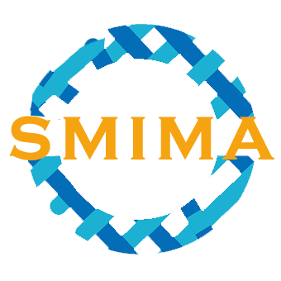 | 第二届智能材料、智能制造与自动化国际学术会议（SMIMA 2019）  2019 2rd International Conference on Smart Materials,  Intelligent Manufacturing and Automation (SMIMA 2019)  时间/Time：2019/02/22-24 地点/Venue：中国·深圳Shenzhen, China  网址/Website：http://www.smima.org/ 邮箱/Email：icsmima@163.com  参会回执表 (Listener Form)

_____________________________________________________________________________________________

基本信息/ Personal Information *
稿件编号/
Manuscript Number：
姓名/ Name： |  |  |  | 性别/ Gender：
职称/ Job Title： |  |  |  | 职务/ Position：
国家/Country： |  |  |  | 微信/ WeChat：
电话/ Phone： |  |  |  | 邮箱/ E-mail：
学校/ University：
研究领域/
Research Area：
随行人员/ Retinue： | 若有随行人员，请复制此表并填写完整后返回.  If there is any retinue, pls copy this form, fill it and reply to us together.
会议信息来源/ Where to Get the Conference Information | (AEIC官方渠道、邮箱、科学网、知网、学者网…） |  | 其他渠道/  Other Way
参会意愿/ Presentation & Preference *
◻ 特邀报告/Keynote Speeches（Upload detailed academic CV）
◻ 听众/ Listener
◻ 口头报告/Oral
◻ 墙报展示/Poster
*Final decision will rest with the Scientific Committee
注册费用/Registration Type & Fee *
Registration Type |  | 注册费（人民币） |  |  | Fee（By US Dollar）
听众/ Listener |  | 1200 RMB/人 |  |  | 180 USD / per person
*已投稿者根据投稿费用缴费即可，无需另缴参会费；
The participants who have submited papers only need to pay the registration fees, no need to pay additional participation fees;
*非投稿者及其他随行人员如需参会须缴纳1200元参会费。
*The participants who not submit papers and other retinues are required to pay 1200 yuan/per person (180 USD/per person) for the participation fee.

房间预订/Hotel Reservation *
房间类型/Room Type |  |  | 房间数量/Room Quantity
入住日期/Check-in Time |  |  | 退房日期/Check-out Time
会议地点：深圳富邦国际酒店：（Click）
Venue: Shenzhen Fubang International Hotel (click)

标准单人房，368元/天 (一个床位、Interenet网、一份早餐)
Standard Single Room：60USD【 Internet and breakfast included】
标准双人房，368元/天 (两个床位、Interenet网、两份早餐)
Standard Twin Room: 60USD【Internet and breakfast included】
* 入住价格请在酒店前台以会议主办方的名义按优惠价入住即可.
When you arrive the hotel, just let the front desk know that you are come to take part in the AEIC Conference-SMIMA 2019, then they will help you to check in with cooperate rate.
报告题目及摘要/ Title & Abstract *
报告人/ Author |  |  |  |  | 个人照片  Photo
报告题目/Title |  |  |  |  | 个人照片  Photo
摘要/ Abstract
_________________________________________________________________________________________________________________
*Please fill in, save the file and feedback via Email: icsmima@163.com
*Registration fees includes conference document, banquet, lunches, gifts, tea break.
*此表复制有效，请填写完整后发送至会议秘书处：icsmima@163.com。注册缴费、住宿、议程等安排请查看后续会务邮件，或登陆大会网站：http://www.smima.org/ 关注会议最新动态。

